Sunrise Preschool

We are delighted to have you and your child as part of our nursery. This booklet contains a summary of our educational philosophy, details of our curriculum and other practical information you may need. If you have further queries, do not hesitate to contact Meeta Lovage of Didi, the managers.

Sunrise Preschool
55 Coniston Road
London N17 0EX
020 8885 3354
info@sunrise.org.uk

Also included below: Application Form, Learning Journal, Child Protection Policy, Complaints Policy, Behaviour Management policy.

AN INTRODUCTION TO SUNRISE NURSERIES

OUR AIMS, APPROACH AND PHILOSOPHY

Sunrise Nurseries are part of an international, non-profit making educational trust. Their aim is to develop every child towards his or her highest potential by caring for and educating all aspects of their being: physical, emotional, intellectual, creative, intuitional and spiritual.

Our educational philosophy is known as Neo-Humanism and was developed by the Universalist spiritual teacher and activist P.R. Sarkar. In 1955, Sarkar founded “Ananda Marga” (Sanskrit for “The Path of Bliss”) as a socio-spiritual organisation in West Bengal, India. Since then, through the efforts of its many voluntary workers, Ananda Marga has become a global organisation, offering instructions in yoga and meditation techniques and running social projects such as Sunrise Nurseries.

Neo-Humanism goes beyond traditional humanisms by taking into account the welfare of the animate and inanimate worlds, as well as that of our fellow human beings. It is based upon the universal values of individual growth – through education, creativity and spirituality – and loving service to humanity and the created world.

Thus according to our aims and our Philosophy, Sunrise nurseries approach Education on many levels. To develop the child’s physical well-being, suppleness and mental balance, we teach them specially adapted yoga and breathing exercises in addition to traditional sports and games. In order to encourage the exploration and refinement of their senses, our classrooms are stimulating environments full of different shapes, colours, textures and smells. We include the Montessori Method of teaching in our approach, which uses special materials and practical life exercises to develop the children’s sensory motor skills, laying the foundations for later intellectual development.

To foster an ecological consciousness we study nature and care for plants and animals, encouraging awareness that human beings are part of a world and a universe that deserves care.

Our unique curriculum consists of a series of themes from the “cycle of creation”, and ranges through the elements of space, air, water, fire and earth, to plants, insects, fish, reptiles, birds and animals, and from there to oneself, our family, other people, universal family and God or Supreme Consciousness. They complement the Early Years Foundation Stage (EYFS). This provides a unifying framework for the whole range of activities throughout the year, whether creative visualisation and fantasy, lively educational stories, drama, dance, yoga postures or arts and crafts. These themes thus stimulate the child’s intellect but are taught in a holistic way, ensuring that knowledge is not fragmented and compartmentalised but related to, and interlinked with, the elements, experiences and activities of children’s everyday lives.

EARLY YEARS FOUNDATION STAGE

The curriculum for the EYFS in our nursery reflects the areas of learning identified in the Early Learning Goals. The Early Learning Goals cover the knowledge, skills and understanding which the children should acquire by the end of the Reception year.

The three prime areas of learning are:
- Personal, Social and Emotional development
- Physical development
- Communication and Language.

Our teachers working with the youngest children at first focus strongly on the three prime areas, which are the basis for successful learning in the other four specific areas.

The 4 specific areas are:
- Literacy
- Maths
- Understanding the world
- Expressive Arts & Design.

The balance shifts towards a more equal focus on all areas of learning as children grow in confidence and ability.

Characteristics of Effective Learning
When planning and guiding children’s’ activities, our teachers consider the different ways children learn and take this into account in their planning. Characteristics of effective teaching and learning include:
- Playing and exploring,
- Active learning,
- Creating and thinking critically.

The Role of Parents

We believe that all parents have an important role to play in the education of their child. Parents are made to feel welcome and valued in their dealings with all members of staff. We recognise the role that parents have played and their future role in educating the children.

CIRCLE TIME

Great importance is given to the daily circle. Circle time creates a family feeling of togetherness, a chance to share and listen, to sing and dance joyfully. It is a special morning time celebration where the magic and the true heartbeat of the nursery can be experienced by all from the youngest nursery child to the oldest children and by the teachers as well.

Practising meditation in circle time each morning develops the children’s concentration and awareness and most importantly, gives them a direct experience of their own inner life. The children learn to be still and feel love “above and below, around and inside them”
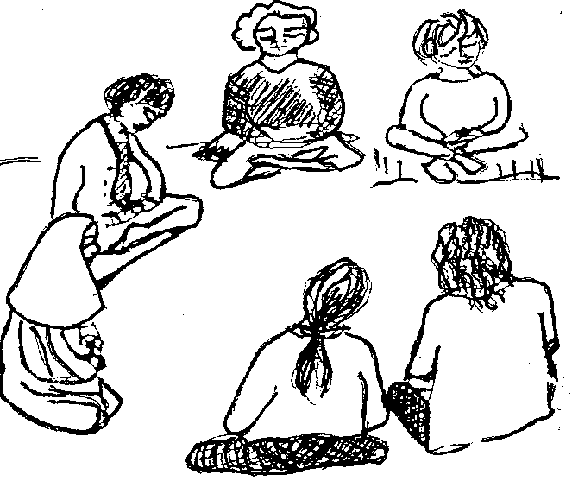
Before meditation time we dance and sing kiirtan with our eyes closed and our arms reaching upwards in a gesture of openness, a willingness to receive positive energy from the universe.
Kiirtan is sung using the powerful Sanskrit mantra Baba Nam Kevalam, which means 'Everything is love, everything is one'. Whilst meditating, the children are encouraged to concentrate upon the meaning of this mantra and the feelings of love in their own hearts. Such meditation and ideation develop in the children a sense of security and peace within themselves and a feeling of love for the universe to which they belong.
After this quiet time the children can listen to a story, enact a drama or have a learning moment. Circle time helps to develop each child's intuitive, creative and spiritual capacity.

OUR TEACHERS

Children flourish in an atmosphere of love and trust between them and the adults who care for them. Sunrise teachers create this in small class settings, where children can comfortably absorb knowledge and positive character traits.

Our core group of teachers are experienced and trained in a variety of methods. They implement the EYFS in their classrooms and may be practitioners of yoga or meditation themselves. We hold regular training days when they can build up more understanding of Neo Humanism and its practical application in the classroom.

We strongly believe that if children are to grow into kind, responsible adults, who respect others and their environment, they need to see these qualities in the adults who love and guide them.

OUR POLICIES

There is a copy of the Complaints Procedure on the wall in the hall.
You will be given/emailed a copy of our Child Protection Policy when you enrol. All policies are in our Policies Folder in the office and are available for consultation at any time.

MEETING PARENTS

Each term, parents will be able to meet their child’s key person for an in-depth discussion, and “tuning in” to the child’s needs, interests and next developmental steps. Parents will also be able to talk to a teacher each time the need arises.

OUTDOOR PLAY

At Sunrise we let the children play outside to get them close to nature in all seasons and weathers. It is important that children can explore the outdoors in a safe environment. It gives children a different learning experience, on a larger, messier, noisier scale than in the classroom.

PRACTICAL INFORMATION

PLACEMENT

The first week of attendance is seen as a settling period. Therefore, depending on need, some children may attend only half days from 9am to 12pm before becoming used to a full day. For the first half-day, we would like a parent to remain for the entire morning session. This enables your child to explore and experience the programme in your presence.

For the first few mornings parents are very welcome to sit with their children in the classroom, encouraging them to feel comfortable in their new surroundings.

Children may be present from 8 am to 6 pm. We would ask that children arrive before 9.30 as this is the time that the morning circle begins.

MEALS
We are a vegetarian nursery and many of our pupils are vegan. In addition to being a vegetarian nursery, all foods eaten on site should follow the yogic sentient diet, which excludes onion, garlic and mushrooms, as these foods are detrimental to meditation and concentration. In addition, due to some children having severe allergies, please no peanuts/nuts.

Please avoid including crisps for your child or sweets and chocolate. There are plenty of healthy alternatives on the market for you to choose from.

A combination of possible suggestions are:
- cheese or marmite and cucumber sandwich/roll/wrap
- cottage cheese
- cheese chunks
- pasta or couscous salad
- raw carrot sticks and cucumber chunks
- red pepper/sweetcorn
- sunflower/pumpkin seeds
- olives
- crackers and savoury biscuits
- plain biscuits
- yoghurt

Please provide fresh fruit for the morning and afternoon breaks.

On children's birthdays, parents are welcome to bring healthy cake or healthy party food (not full of colour or additives). Homemade cakes can be baked using an egg substitute powder obtained from health food shops.

NECESSITIES

Each child should be equipped with the following:

- A water bottle
- At least one complete change of clothes including a warm layer and socks.
- Wellington boots
- Nappies and baby wipes if used
- Slippers
- Warm clothes for outdoor play
- A raincoat
- A bag to hold all of these, not a plastic supermarket bag please.
COMMUNICATION

The parents committee, to which all parents automatically belong, holds meetings from time to time with the manager and teachers as a forum for general communication. We also produce a regular newsletter with the latest news. Please check the front door and the hallway pin board for details of meetings, copies of the newsletter and other notices.
Parents are free to ask to meet nursery teachers to discuss their child’s progress at any time. From March to June is a particular period when parent/teacher consultations are arranged.
Daily sheets or verbal feedback on eating, sleeping, toilet and other significant events are given to nursery parents of 2 year olds.

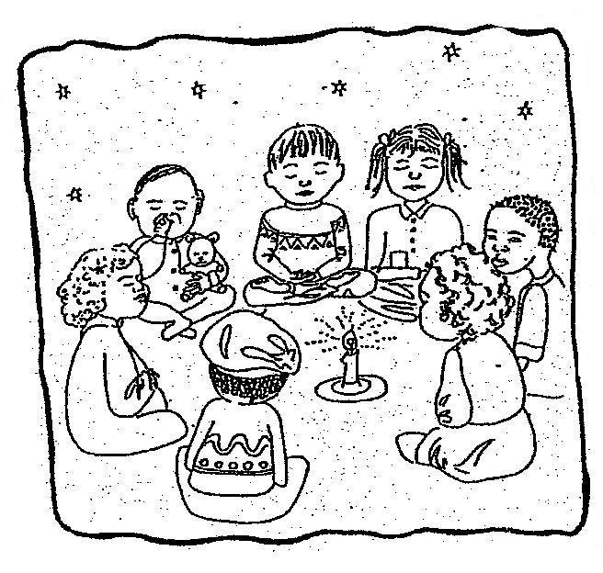

HOLIDAYS

We have the following holidays each year
- Two weeks at Christmas
- One week at Easter
- Three weeks in the summer
- 2 days in the middle of each term

PERSONAL TOYS, JEWELLERY AND MONEY

We would ask that children do not bring personal toys, jewellery and money to nursery. These items often become a source of distress rather than comfort when other children wish to play with them or if they get lost or broken.

WITHDRAWALS

Should it be necessary to withdraw your child from the nursery, we ask that you provide us with one month notice.
This period is covered by your initial deposit, which without sufficient notice, we are unable to return. Thank you.

NURSERY GOVERNMENT FUNDING

2 year-olds
If you are receiving government support or are on a low income, your child may be eligible for 15 hours of funding. To find out if you are eligible, please visit Haringey Free for 2s Eligibility Check or your local council website.
Please note that funding does not cover half term or school holidays. If you would like your child to attend during that time, normal fee rates apply. Please see the Haringey Term Dates. The nursery receives the funding directly from Haringey Council

3 to 5 year-olds
The term after your child turns 3, you are eligible to apply for a Nursery Education Grant from Haringey council. The nursery applies on your behalf and only your signature will be needed.
This entitles your child to the equivalent of 15 hours of nursery education. We provide for flexible hours: 9am to 12 pm, five days a week, or 1pm to 4pm, five days a week, or 15 hours spread over 3 days e.g. 9am to 2pm. If you need your child to stay for longer, we just deduct the cost of 15 hours from your bill. (See fees above)
For the children attending 15 hours only, the nursery receives the funding directly from Haringey Council.
You may be entitled to 30 hours free nursery education per week. Working parents of 3-year-olds may be eligible to Extended Free Early Education and Childcare, which is an extra 15 hours per week. In order to be eligible, both parents must be working and meet the eligibility criteria.
To find out if you are eligible please visit the HM Revenue website.

Please note that funding does not cover half term or school holidays. If you would like your child to attend during that time, normal fee rates apply

FEE STRUCTURE

An initial deposit of one month fee to be paid before commencing.
We ask that nursery fees are paid on a monthly basis as follows.
1 to 3 year-old fees – monthly – 11 months September to July, from 8 am to 6 pm.
5 days £1129
4 days £1045
3 days £878
2 days £585
1 days £293

1 to 3 year-old – weekly -for 46 weeks for children attending variable hours
5 days £270
4 days £250
3 days £210
2 days £140
1 day £70

3-5 years – monthly – 11 months September to July.
The fees given below are payable by parents for a child who is eligible for 15 hours of free nursery education but attends the nursery for longer hours.
5 days £652
4 days £562
3 days £443
For these children, two days are counted as the 15 hours free voucher. The nursery receives this funding directly from Haringey Council.
Any places outside these standard plans are offered at the manager’s sole discretion. Our hourly rate is £9 per hour.
OUR BANK DETAILS

Payments by standing order can be made to

Sunrise Education Trust
Cooperative Bank
Sort code: 08-92-99
Account number: 65979493

Please ensure that your child’s name is entered into the account records when setting up the monthly standing order mandate with the bank and inform Didi or Meeta the date from which payments will start.

ORGANISATION OF OUR NURSERIES
Our Structure:
Sunrise is run by the trustees and the management committee members
1. Sunrise Education Trust
The trustees oversee Sunrise's property and land transactions, along with its loans and mortgages. They also ensure that the nurseries are being run in accordance with the aims and ideals of Neo-Humanistic education.
The trustees are: Govinda Lovage
Pippa Robins
Yogeshwarii Ramaswamy
2. Management Committee.
The management committee meets every two months and is responsible for making and implementing decisions regarding:
▪ Staff conditions
▪ Upkeep and renovation of the buildings
▪ Finance (monthly reviews and budgets)
▪ Enrolment policy
▪ Nursery policy
▪ Administration
▪ Curriculum
Management committee structure:
Chair person : Meeta Lovage
Secretary : Didi Ananda Manika
Four sitting members from the local Community, or former staff or teachers
Govinda Lovage
Saradadevii Hull-Jurkovic
Yvonne Byrd
Piera Freccero
Address:
1 Cazenove Road, London N16 6PA

